Lesson 1: Biodiversity Introduction
Name: _________________________________________ Period: ___________
Directions: Fill in this sheet as you are watching and listening to the PowerPoint.
1. Write the definition for an ecosystem?

2. Biotic means ________________________________________________.
Abiotic means _______________________________________________.

3. Name a familiar ecosystem: ______________________________________
List some of the living things found in this ecosystem. How are they related?

4. What is a riparian ecosystem? Name some animals you would expect to see there.

5. Compare your list from #4 to your partner’s. Are they the same? Write down any organisms they had on their list that you did not.

Class list of living things from the Riparian Ecosystem

6. A riffle is ______________________________________________________.
A pool is _____________________________________________________.
7. What effect(s) do you think leaves falling in the stream have? How can the living things in the stream use them?

8. What is a watershed?

11. Write a definition for biodiversity?

12. Where are we going on our fieldtrip?
_____________________________________ and _________________________________________.
13. Why do you think we are going there?

Lesson 2: Experimental Set-Up Worksheet

Name: _________________________________________ Period: ___________
- Outline the procedure you will follow for this experiment:

- What do you think you will find in your leaf pack?

- Choose one of the organisms you listed in question #2. What do you think might affect whether this organism lives in the leaf packs you will put in the stream? Organize your ideas by filling out the table below.

Ecosystem Component | Name of the one organism you picked:
Dispersal –
Can your organism get to the leaf pack?

Abiotic resources and conditions – does your organism have specific abiotic requirements for survival (temperature, light, dissolved oxygen?) | Temperature: Hot…………Medium………….Cold  Light: High………….Medium…………..Low  Dissolved Oxygen: High………….Medium…………..Low  Do you know if it requires anything specific?
Biotic resources and interactions-  a. Would your organism have enough food?  b. Are there competitors or diseases?  c. Are there predators to worry about? | a.  b.  c.
- During this experiment, you will be testing leaf packs in two different parts of the stream – a part of the stream that is quiet, deep, and calm (a pool), and a part of the stream that is moving quickly and is shallow (a riffle). Do you think you will find different kinds of organisms in the leaf packs in the different parts of the stream? Why or why not?

  - Stream Characteristics Data Sheet
Name: _________________________________________ Period: ___________
Map your 10m x 10m site and create a legend for important features:

10 m

10 m
Legend:

Whole Group Activities
Measure a 10 meter segment of your stream and collect the following measurements:
Stream Characteristics
Find the average width and depth of your 10 m stream segment by measuring the stream at three different places along your 10 meter segment (beginning, middle, and end).
Location | Position along 10m | Width at this location | Depth – in middle of stream
Beginning | 0m
Middle | 5m
End | 10m
Average
average depth or width = sum of depths or widths
number of samples taken
Stream velocity:
Drop a leaf or stick at the beginning of your stream segment and record the time it takes your object to reach the end.
Time (in seconds):
Now calculate the velocity in meters per second (10 meters divided by time seconds ):

Abiotic Factors: Measure Temperature, DO, and turbidity in 1 pool and 1 riffle. Add data from the stream velocity measurement.
 | Pool | Riffle
Water Temperature
(C°)

Dissolved Oxygen
(mg/L)

Turbidity
Stream Velocity m/s

Lesson 3: Macroinvertebrate Data Collection

Names of group members:
Place in stream (circle): Riffle or Pool

- Empty the leaf pack according to your teacher’s instructions.
- Separate the animals you find into groups and identify them using the Leaf Pack Sorting Guides.
- Count the animals in each group and record your data in the table on the next page. Take notes about sizes and how you made your groups.
Major Groups  Common name | Number of individuals | Notes
Stoneflies | 2 | Seen eating a smaller invert
Dragonflies | 3 | Sizes: One big with skinny tail and one small with fat tail
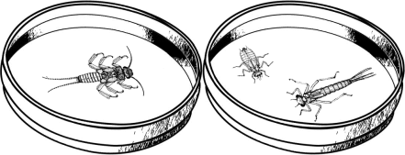
Example
Major Groups  Common name | Number of individuals | How did you know the animal you found was in this group? |  | Feeding Group
Stoneflies
Mayflies
Dragonflies
Damselflies
True Flies / Black Flies
Crane Flies
Caddisflies
Snails
Beetles
True Bugs

Stream Biology Briefs
In aquatic ecosystems, scientists often categorize organisms by how they feed. This includes observation of the organisms in their habitat, and examining them under a microscope to investigate their morphology; the study of the form, structure and configuration of an organism. This includes aspects of the outward appearance (shape, structure, color, pattern) as well as the form and structure of the internal parts like bones and organs.

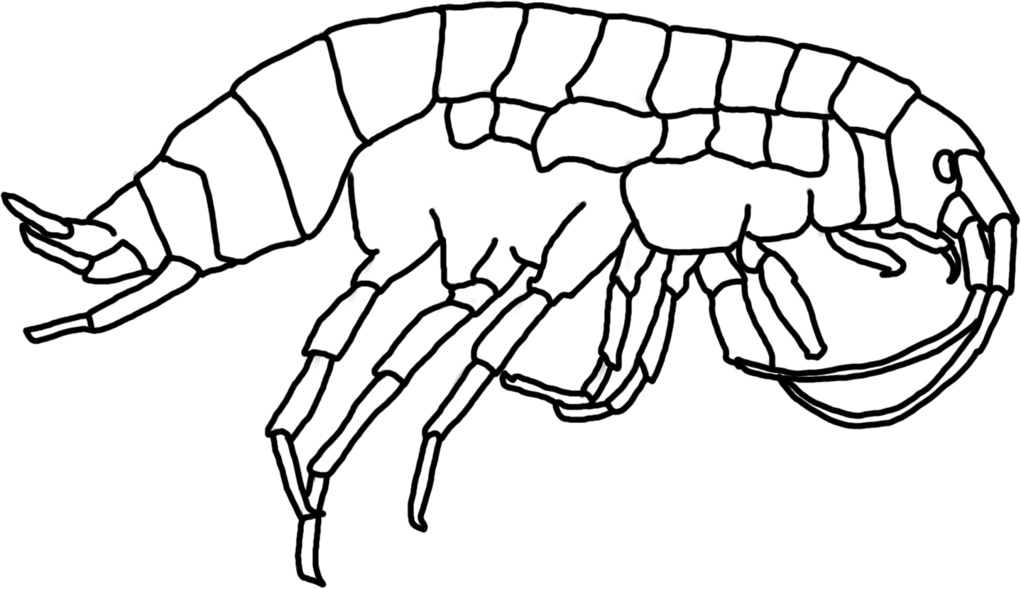
CLASSIFICATION BY FEEDING GROUP
Shredders: These animals take detritus, such as leaves, and break it into smaller particles or “skeletonize” it. Microbes colonize the leaf litter first, followed by the larger invertebrates such as the cranefly, some caddisflies & stoneflies, and amphipods (at left). The crane fly breaks down the leaves from the trees and makes the energy and nutrients in the leaves available to other aquatic organisms.

Collectors (both gathering and filtering): Some organisms are filter-feeders, spinning nets to catch fine particles of detritus. Others feed on detritus at the bottom of streams and ponds. These animals include the net-spinning caddisfly, blackfly larvae, midge larvae, clams, and some mayflies. Net-spinner caddisflies construct a mesh net for filter feeding, but this net is usually destroyed during collection. Black fly larvae and midge larvae have “fans” on their heads to capture material floating in the water. Some scientists separate out the scavengers from this group, but we will include scavengers.

Scrapers: Scrapers include animals that have mouthparts they can use to graze on hard surfaces such as rocks. They have to be strong to hold onto the surface while they feed. Many of these animals have a hard shell (such as the snail or water penny) to protect them from the high energy of the water. The water penny scrapes diatoms from the surface of rocks and then eats the material as it moves, since it is sheltered from the current by the hard plates. These animals include most snails, the water penny beetle, and some mayflies.

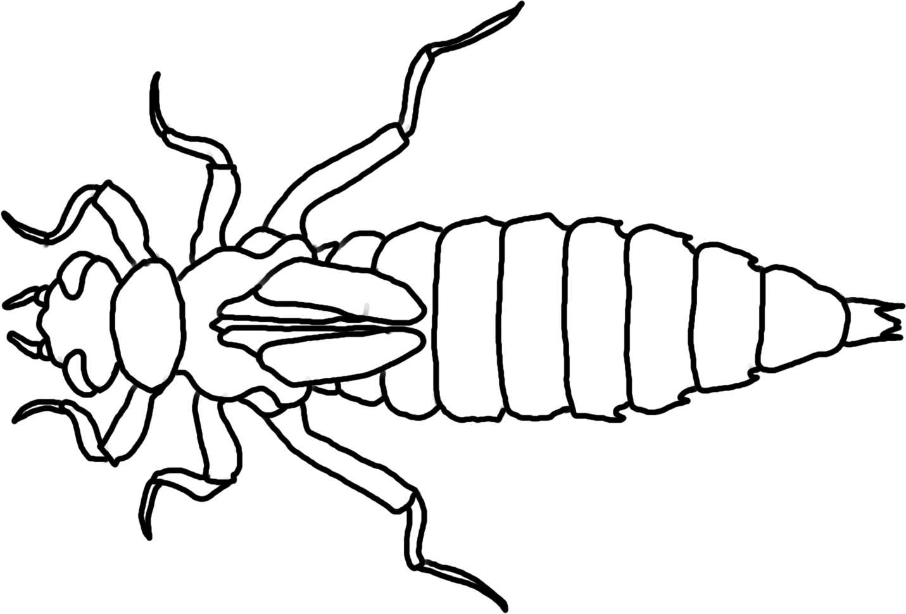
Predators: These animals have large mouthparts consisting of two opposing jaws which they use to kill other smaller invertebrates. Dragonflies (at right), damselflies, and the dobsonfly are part of this group. Dragonflies and damselflies have a large, extendable lower “lip” (labium) that can engulf very large prey, with mature dragonflies sometimes eating small fish. This lip covers the other mouthparts of the larvae, allowing it to capture large animals and tear pieces of their prey while still moving around on all six legs. Some scientists separate out parasites from this group, but we will include them here.
Decomposers: These organisms colonize leaf surfaces and use the leaves for food: microbes such as bacteria and fungi.
Producers: These organisms do photosynthesis. They make their own food, using sunlight to transform carbon dioxide and water into sugar plus oxygen. Producers include trees, diatoms, and algae.

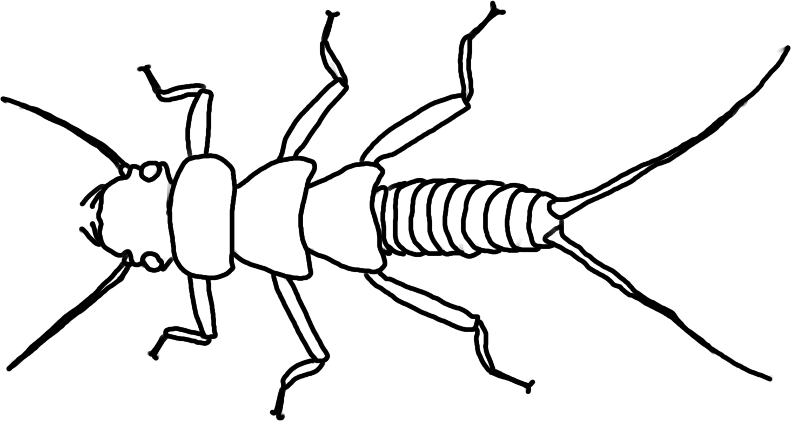
Stoneflies (Order Plecoptera)- Most stonefly are predators; some are shredders. Mouthparts determine whether they are shredders or predators. Shredder mouthparts are directed downward and are shaped for cutting and grinding, while predator mouthparts project forward and are very sharp and pointed. Common prey are midges and black flies along with mayflies. Lives in water with 8-12 mg/L of dissolved oxygen.
Dragonflies (Infraorder Anisoptera; order Odonata) – Predators of anything smaller-as young larvae they eat mostly zooplankton, and as they grow larger they will eat mayflies and even small fish. Lives in water with 4.1-7.9 mg/L of dissolved oxygen.
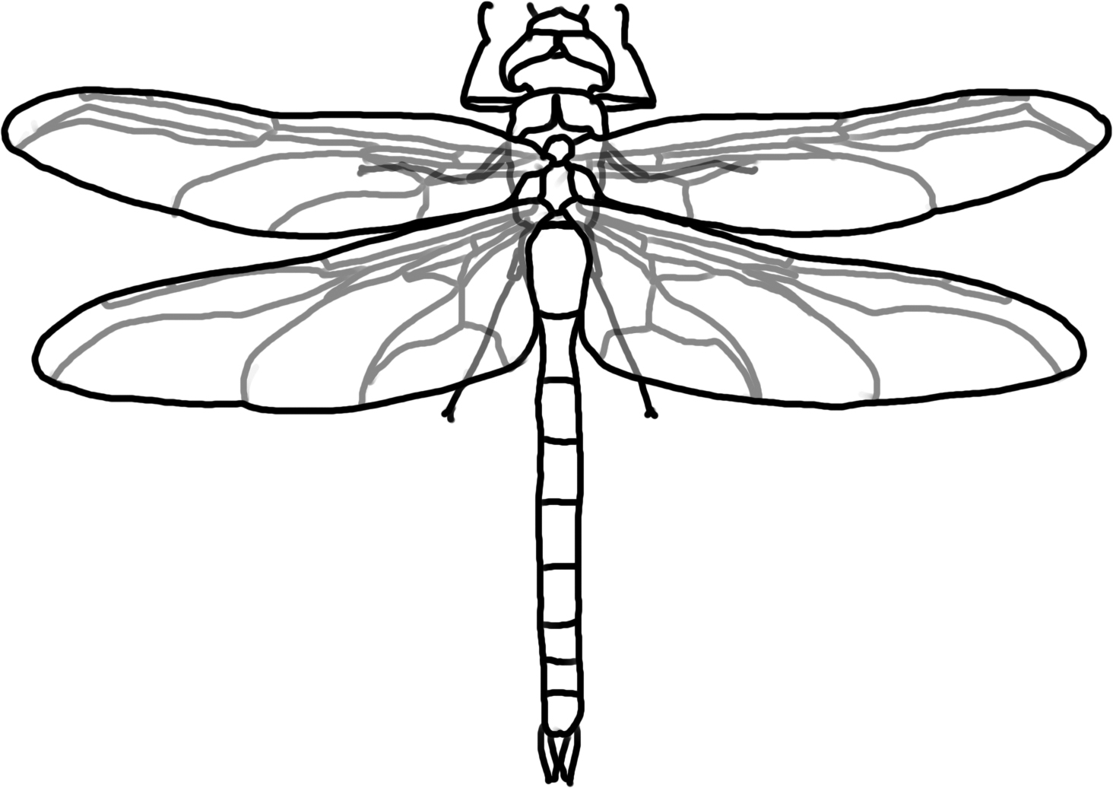

Damselflies (Suborder Zygoptera; order Odonata) – Aquatic nymphs hatch from eggs that are laid in the water. Many overwinter as nymphs, which crawl up on vegetation in the spring to emerge as adults. They are predators and live in water with 4.1-7.9 mg/L of dissolved oxygen.
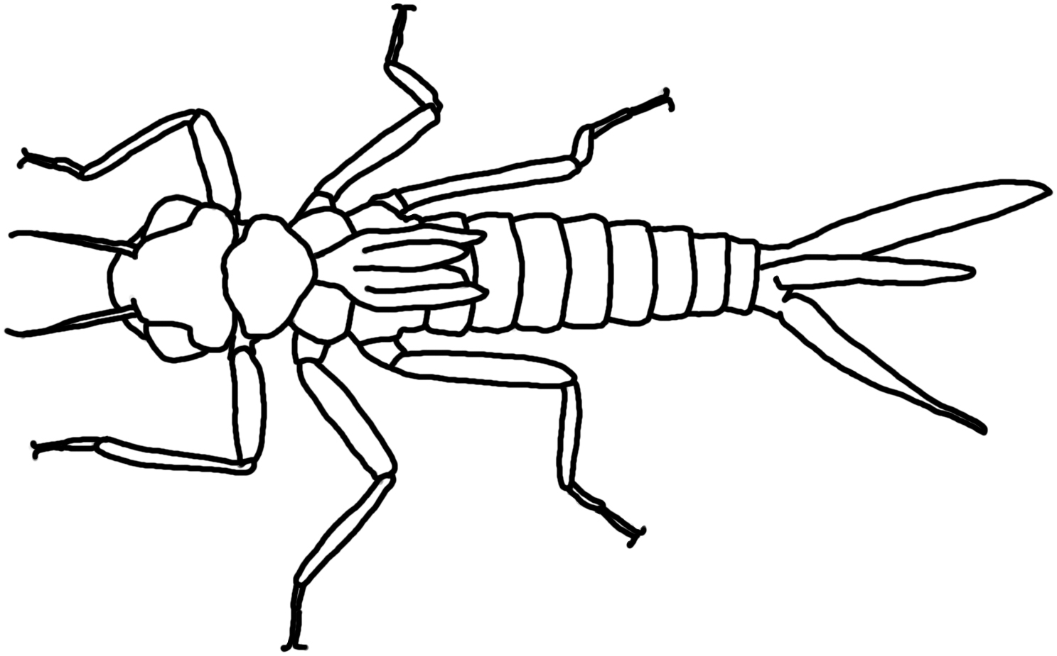
Mayflies (Order Ephemeroptera) – Overwinter as aquatic nymphs. Diet is mostly algae or detritus; mayflies are either collectors or scrapers (76% of the families are collectors, 19% are scrapers, and 5% are predators). Lives in water with 8-12 mg/L of dissolved oxygen.
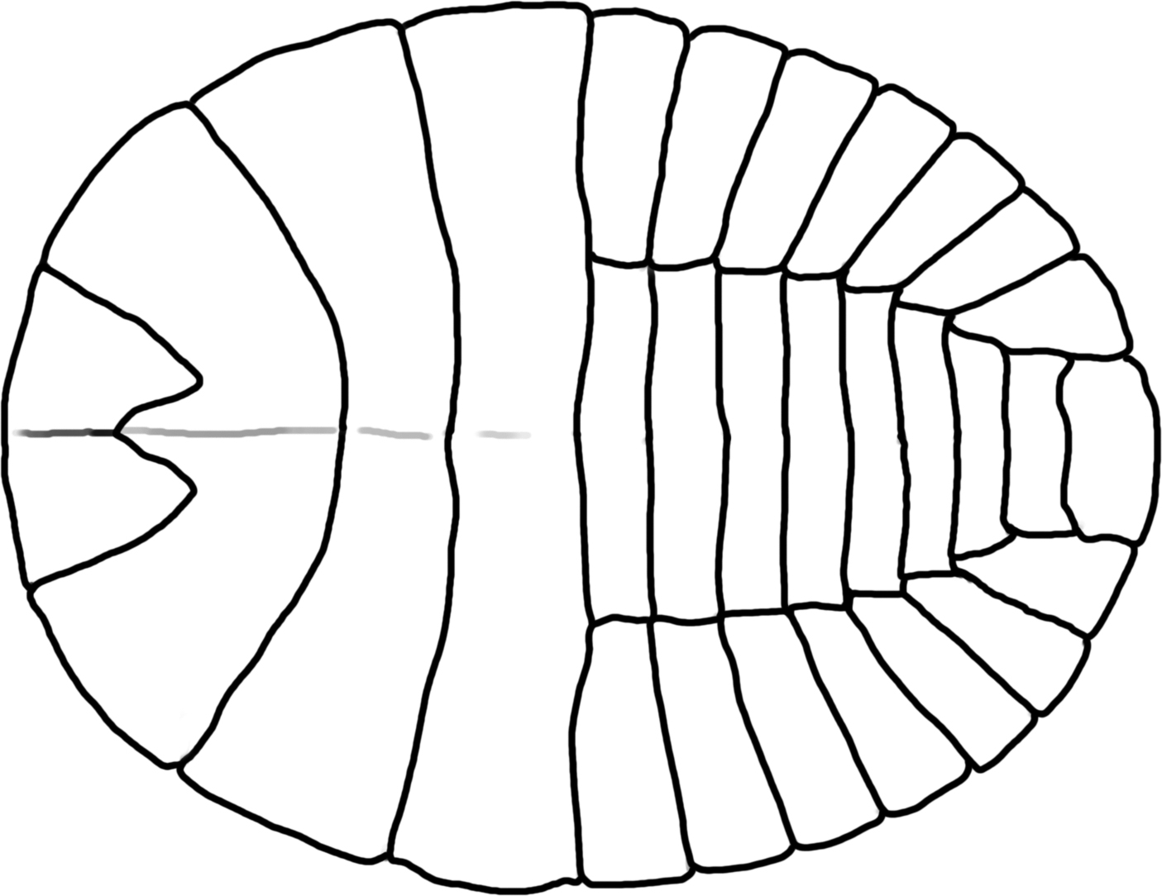
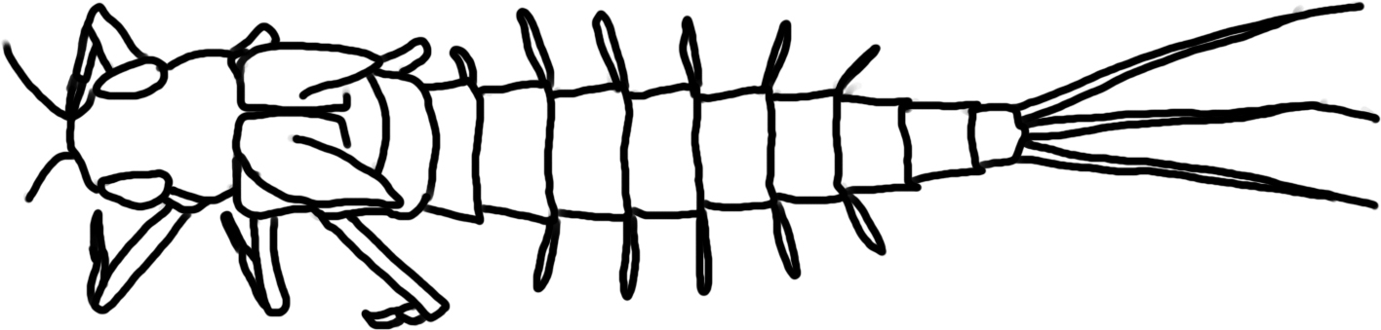
Water penny beetle (Order Coleoptera) – Flat shaped beetle that often curls up when disturbed, and has a strong grip to allow it to move across surfaces in highly turbid water. Water pennies are scrapers who graze on algae on rocks. Lives in water with 8-12 mg/L of dissolved oxygen.

Whirligig Beetles (Order Coleoptera) - Beetles that swim on the surface or underwater and are primarily collectors. Lives in water with 8-12 mg/L of dissolved oxygen.
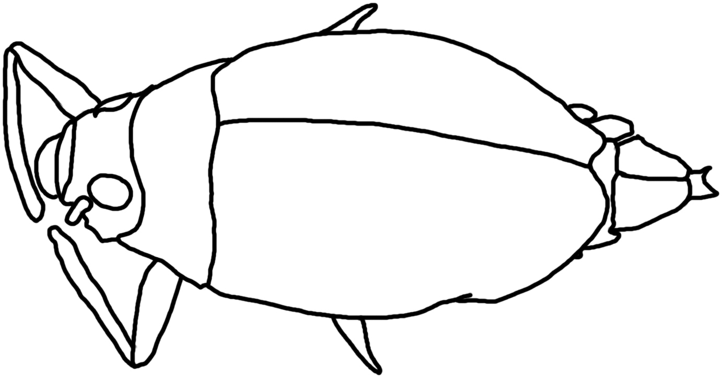
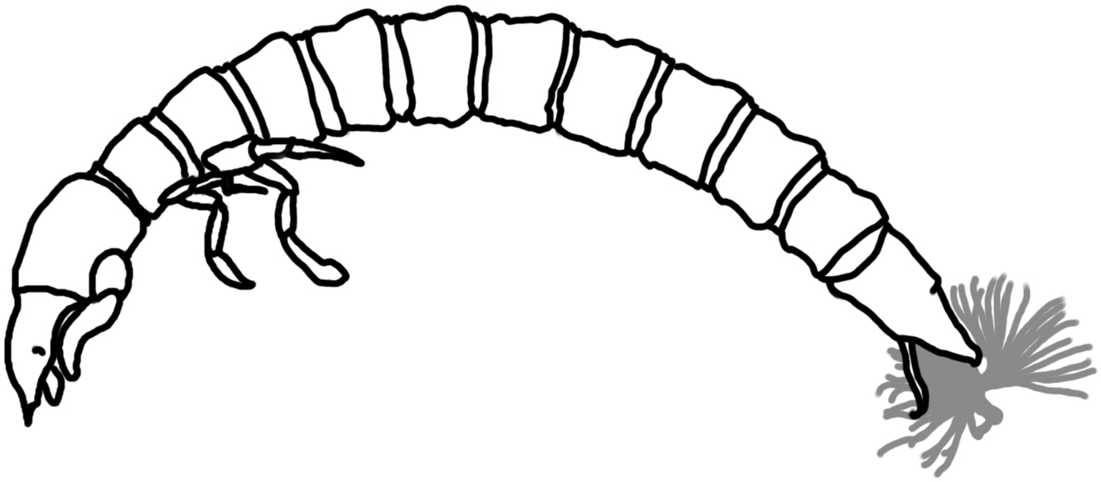
Riffle beetles (Order Coleoptera) – Small, torpedo-like larva with circular stripes or rings around the body, they are primarily collectors that eat diatoms and algae. Lives in water with 8-12 mg/L of dissolved oxygen.

Midge larvae (Family Chironomidae, Order Diptera)- Collectors that filter organic components of sediment & algae. Lives in water with less than 4.0 mg/L of dissolved oxygen.

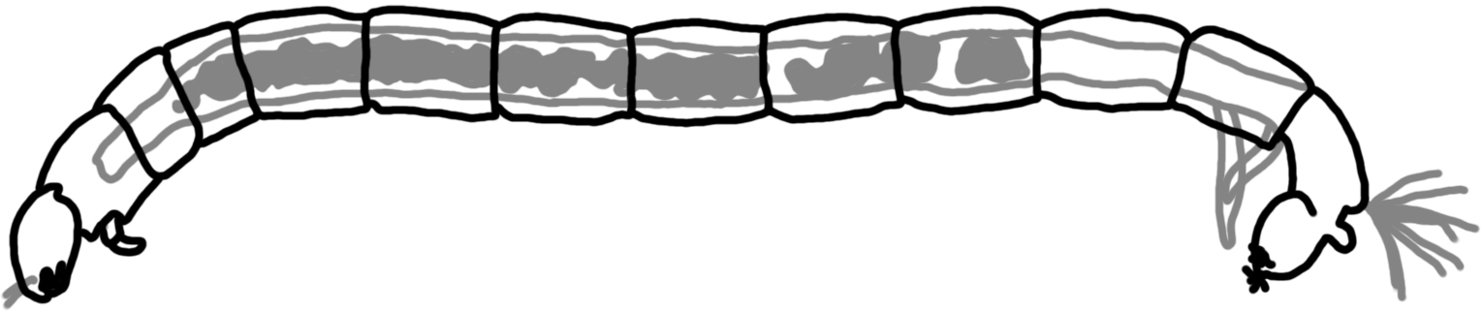
Blackfly larvae (Family Simuliidae, Order Diptera)- Collectors; they hold onto the substrate with tiny hooks and then extend a foldable “fan” into the stream, filtering particles of food (bacteria, detritus, algae) into the fan which is then scraped into its mouth every few seconds. Larvae are very small – between 3 and 12 mm long. Lives in water with less than 4.0 mg/L of dissolved oxygen.
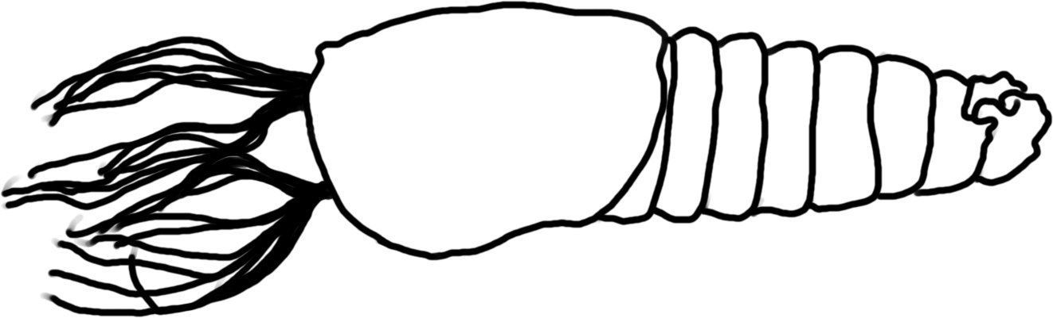
Crane Fly Larvae (Family Tipulidae, Order Diptera)- shredders; break down leaves from trees. Crane fly larvae often look like large worms or maggots, and can be up to 2” long (10-100mm). (Crane fly from genus Hexatoma are engulfer-predators.) Lives in water with 4.1-7.9 mg/L of dissolved oxygen.
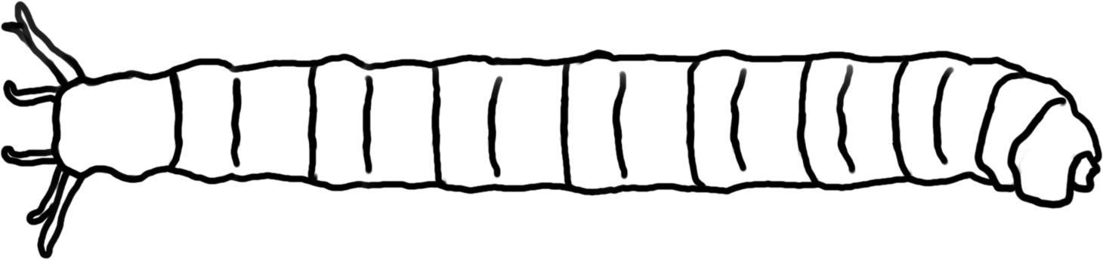
Dobsonfly larvae (also called Hellgrammite; Subfamily Corydalidae, Order Megaloptera)- Predators of any small invertebrate. Lives in water with 4.1-7.9 mg/L of dissolved oxygen.
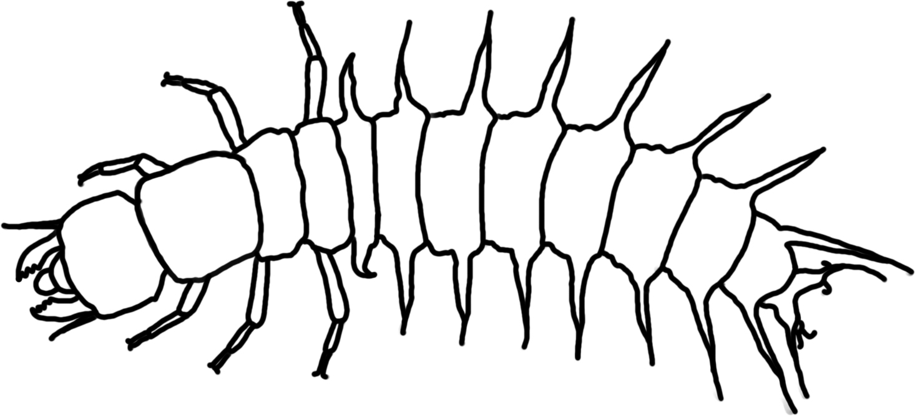
Alderflies (Order Megaloptera) – Aquatic larvae are active predators that feed on aquatic insects, worms, crustaceans, snails and clams. All are predators. Lives in water with 4.1-7.9 mg/L of dissolved oxygen.
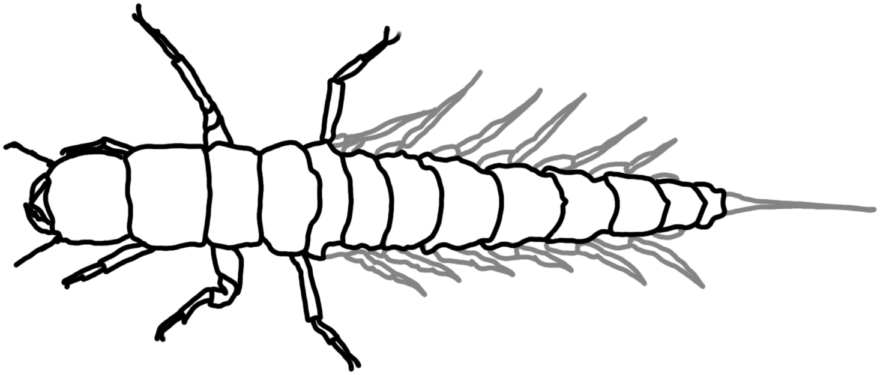
Caddisfly larvae- case makers (Order Trichoptera)- most caddisflies that construct cases of small stones are shredders of detritus and algae. Lives in water with 8-12 mg/L of dissolved oxygen.

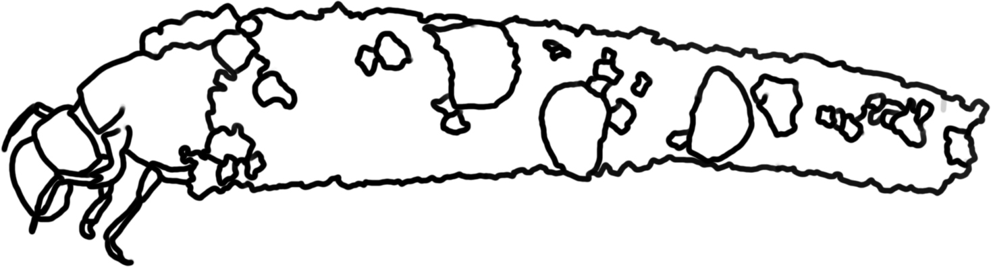
Free-living Caddisflies (Order Trichoptera)- are mostly predators of smaller invertebrates or scavengers. Lives in water with 8-12 mg/L of dissolved oxygen.
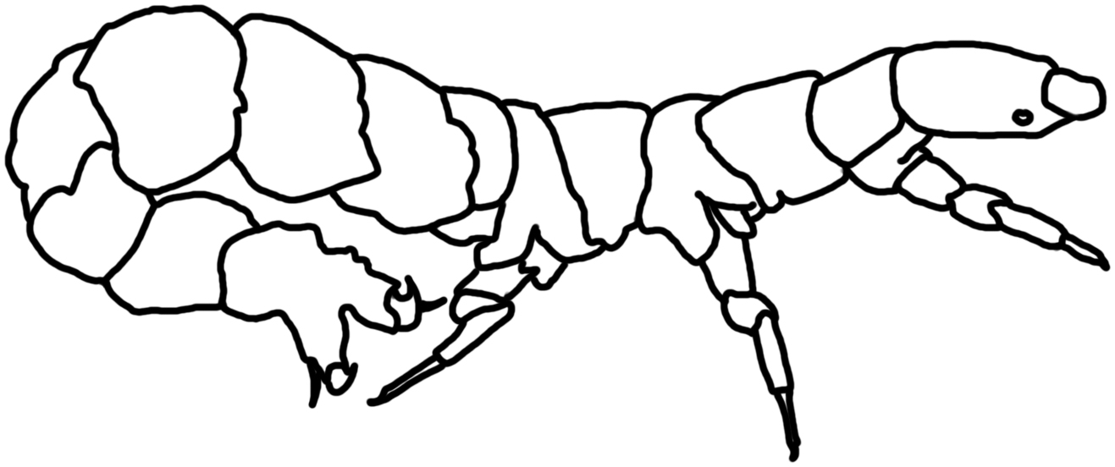
Net spinner Caddisfly (Order Trichoptera; Family Hydropsychidae) – Collectors who spin nets to catch fine particles of detritus. Lives in water with 4.1-7.9 mg/L of dissolved oxygen.
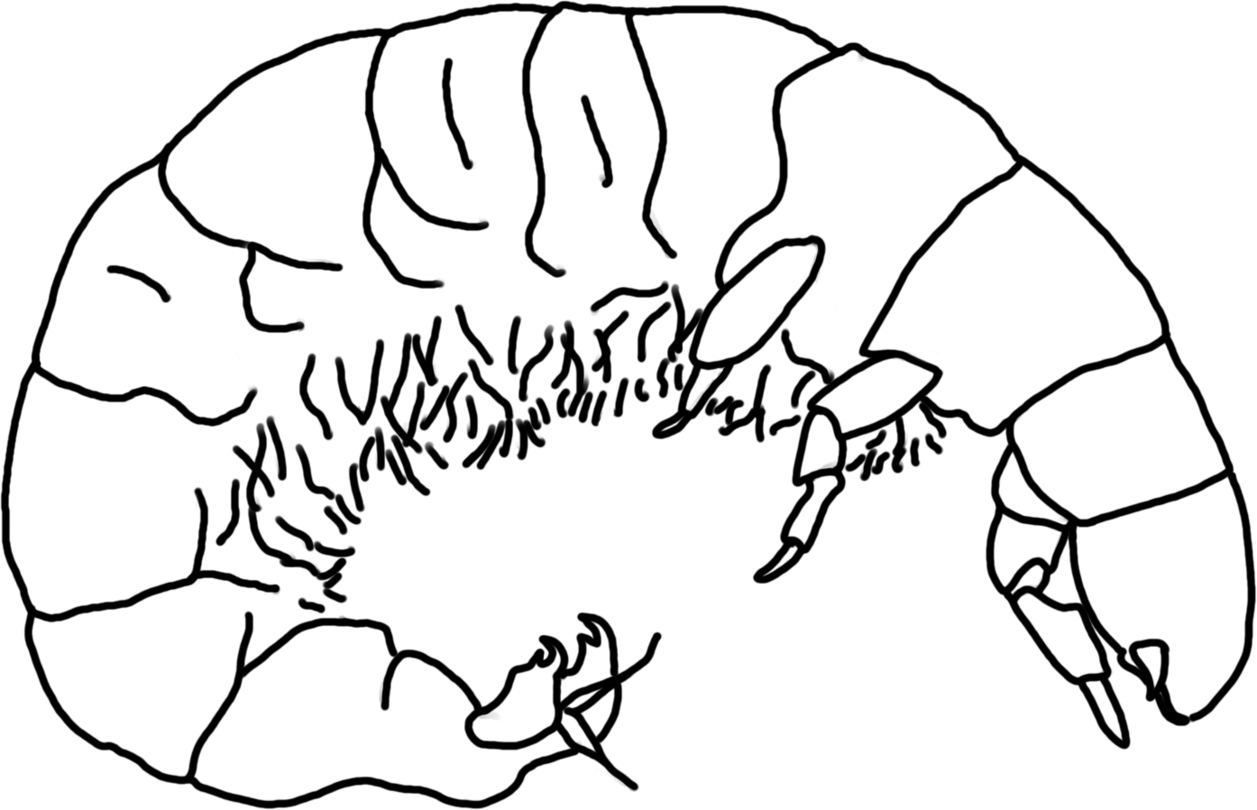
Scud (Order Amphipoda; also called sideswimmers and amphipods)- Shredders who eat mostly detritus, algae, bacteria, and any recently dead organisms. Lives in water with 4.1-7.9 mg/L of dissolved oxygen.
Sowbugs/Pill bugs (Order Isopoda) – Eat a variety of decaying organic matter. Most are collectors. Lives in water with 4.1-7.9 mg/L of dissolved oxygen.
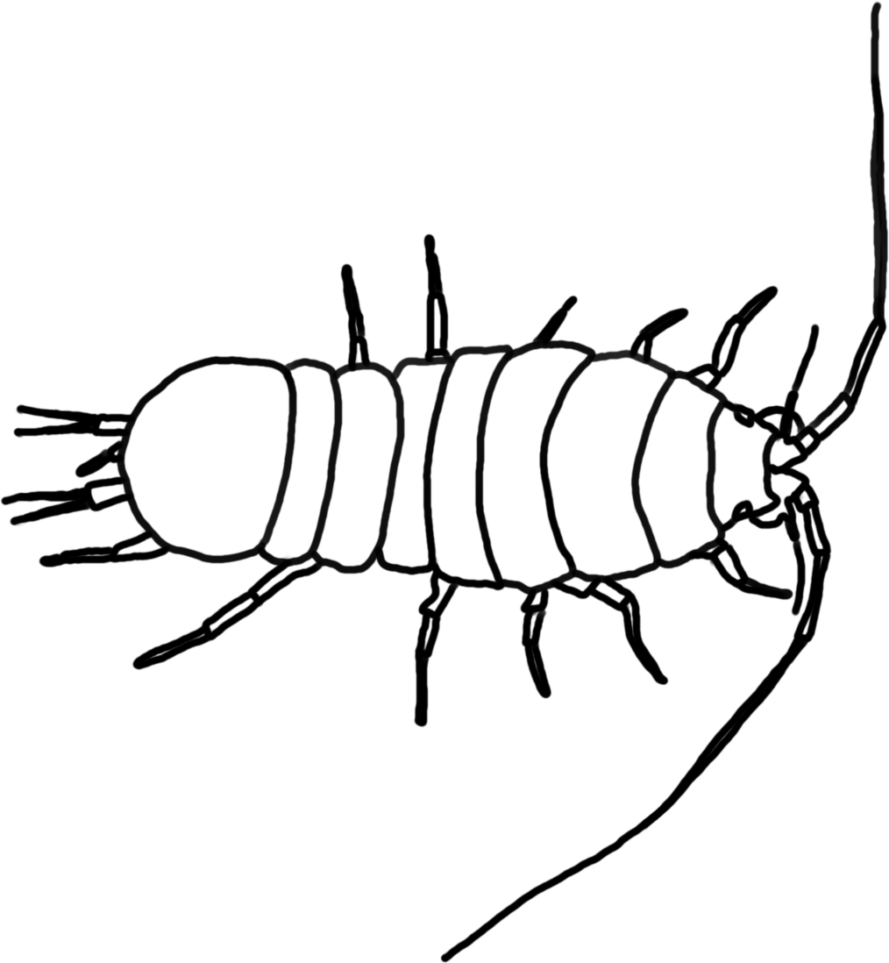
Crayfish (Order Decapoda)- omnivores, primary food is decaying vegetation but will eat anything they can subdue; they are predators and collectors (scavengers). Lives in water with 4.1-7.9 mg/L of dissolved oxygen.
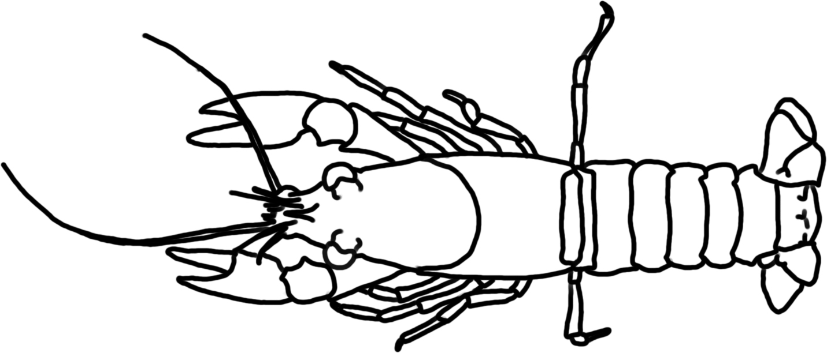
Spiders (Class Arachnids) - Feed by sucking the body fluids from their prey; predators.
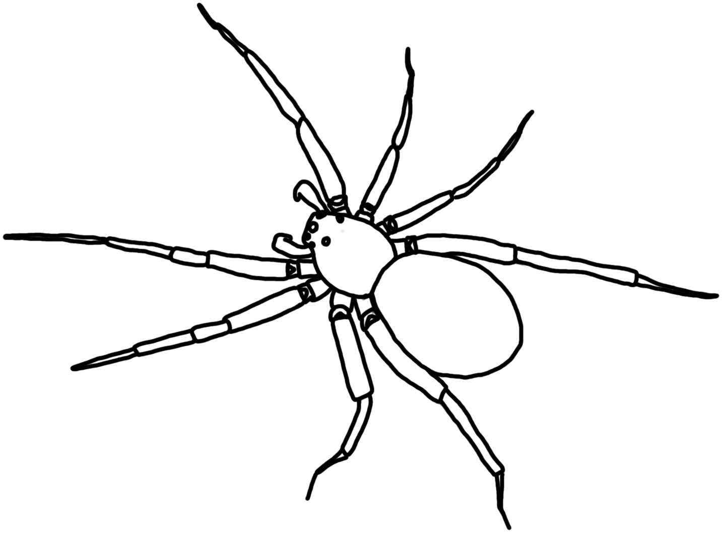
Snails (Class Gastropoda) – Snails scrape algae and other organic matter from ponds substrates. Most snails are scrapers. Gilled snails live in water with 8-12 mg/L of dissolved oxygen, lunged snails can live in water with less than 4 ml/L of dissolved oxygen.
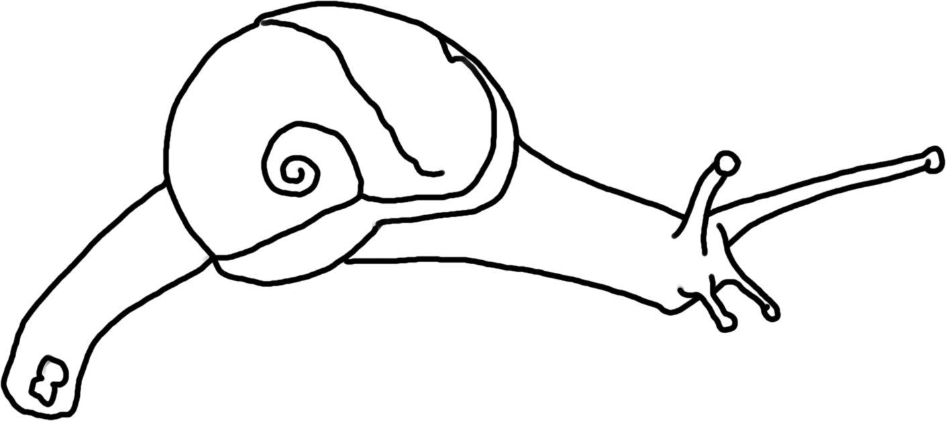
Clams and mussels (Class Bivalvia) – Clams & mussels are filter feeders that live on phytoplankton, zooplankton, detritus and bacteria. They are collectors. Lives in water with 4.1-7.9 mg/L of dissolved oxygen.
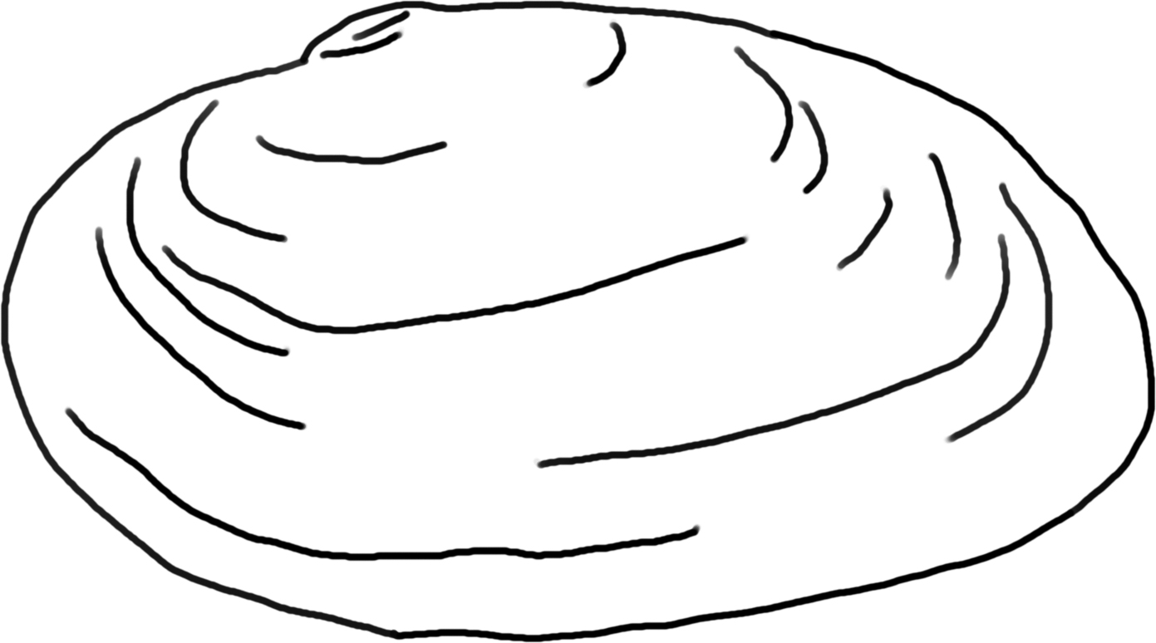

Leeches (Subclass Hirudinea) – Worm-like, soft-bodied organisms with not legs and suckers at either end of the body that attach to hosts and suck fluids from other animals. They are predators (or parasites). Lives in water with less than 4.0 mg/L of dissolved oxygen.

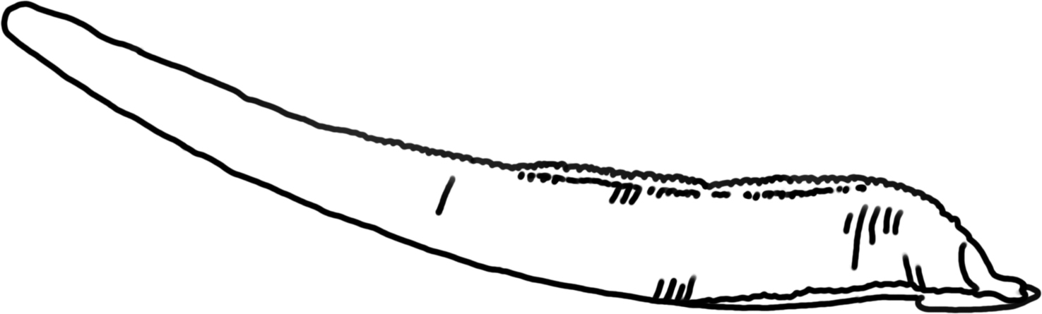

Aquatic Earthworms (Order Oligochaeta) – Most eat detritus, algae and bacteria; these are collectors. Lives in water with less than 4.0 mg/L of dissolved oxygen.
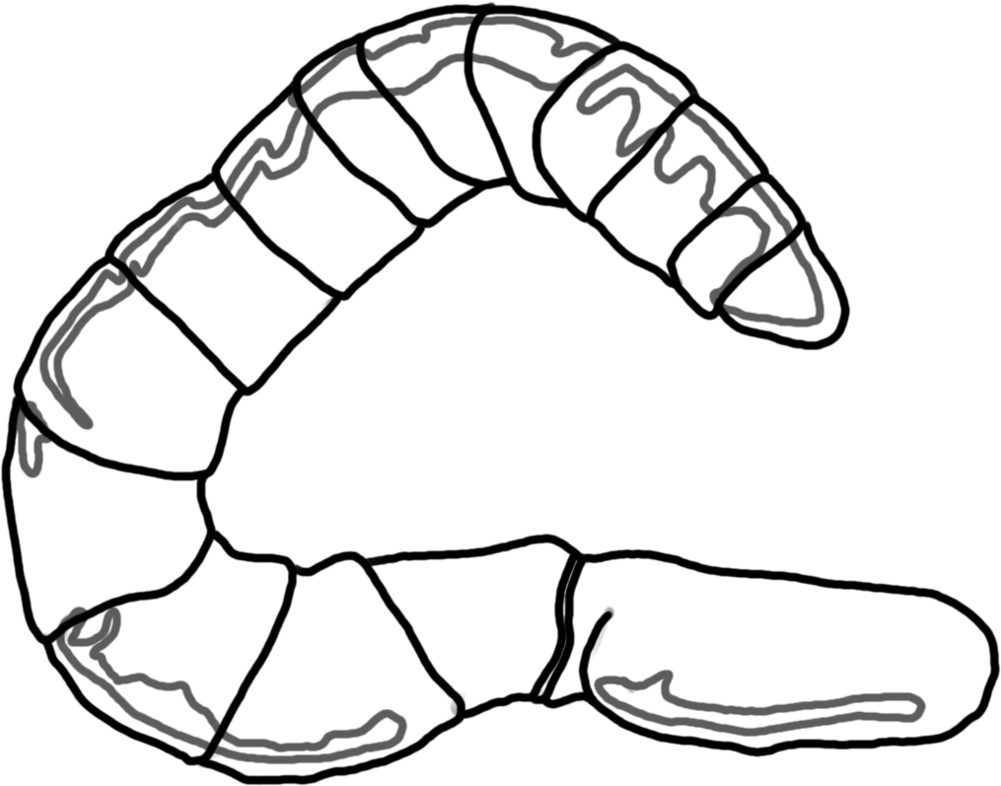
Planaria (Class Turbellaria)- Also called flatworms; predators of soft-bodied invertebrates.

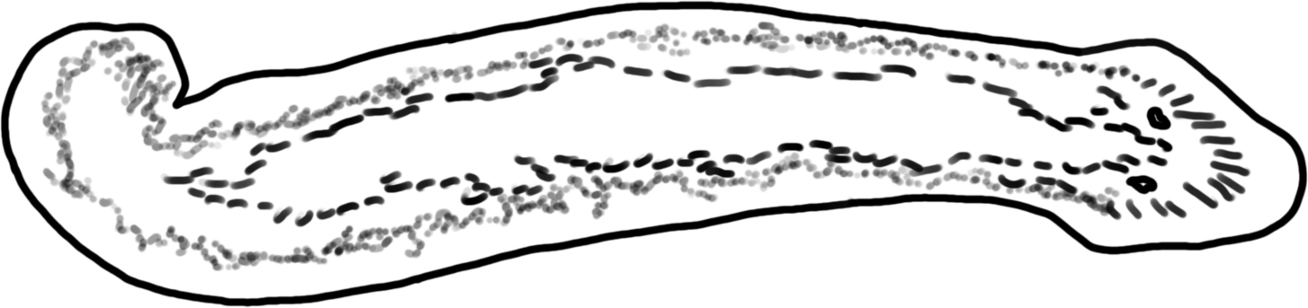

Water mite (Subclass Acari) – These small, tick-like animals live on land and in water. They are parasites or predators of other organisms.
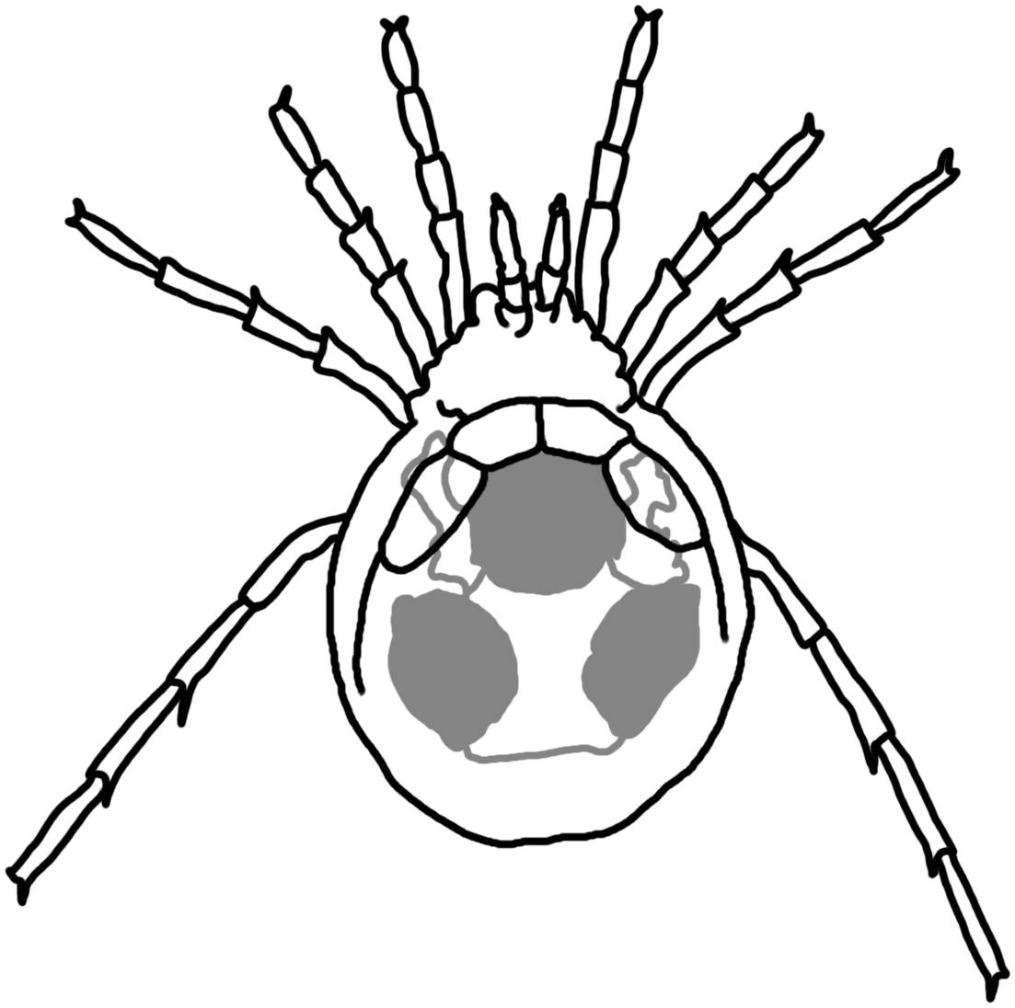
Small arthropods and other protists: mostly consumers (omnivores) that eat small arthropods, protists, bits of detritus, algae etc.

References:
Voshell, J.R. 2002. A Guide to Common Freshwater Invertebrates of North America. McDonald &
Woodward Publishing Company, Virginia.
Thorp, J.H. & A.P. Covich. 2010. Ecology and Classification of North American Freshwater
Invertebrates. Elsevier, Amsterdam.

Lesson 4: Classification Worksheet

Name: _________________________________________ Period: ___________

- Fill in the “Feeding Group” column of the table on your Macroinvertebrate Data Collection worksheet from lesson 3 as your teacher goes through the PowerPoint presentation.

- What do each of the following types of organisms eat?
  - Predators:

  - Scrapers:

  - Shredders:

  - Collectors:

- Why do we classify (put in groups) living things?

- What characteristics could you use to classify things?

- Complete the table below. Hint: The key is to think about what the food does when it is in the environment.
Feeding Group | What organism does this group eat? How does it get its food? | How will a decrease in that food affect the abiotic environment?
Scrapers
Collectors
Shredders

Why are there many different kinds of living things?

Lesson 5: Closer Look Worksheet

Name: _________________________________________ Period: ___________

      - Make a drawing of your organism below.

      - Include a scale bar to your drawing above to show how big you think your organism is.

      - Do you think you know what your organism is?

      - Do you think your organism is an autotroph (makes its own food) or heterotroph? What does it eat?

Answer the following questions at the end of the lesson.

      - Which decomposers did you see?

      - How do bacteria and fungi get their food?

      - How do bacteria and fungi impact the abiotic environment as they get their food?

Optional Lesson: What size is it?
Name: _________________________________________ Period: ___________
Using your Macroinvertebrate Data Collection worksheet copy the names of some of the organisms you identified in your leaf pack. Using the Powers of Ten chart and the Organism Cards, decide what size each of these organisms are. Then record the size in the chart below and decide if each item is living or non-living, and what each thing is made of.

Name of item |  | Size | Is it living or non-living? | What is it made of?  atoms and/or  molecules and/or  a single cell and/or  multiple cells
Microorganisms
1
2
3
4
Macroinvertebrates
1
2
3
4
Other organisms
1
2
3
4
Matter in water
Organic matter
Nitrate molecules
Phosphorus molecules
Oxygen molecules
Water molecules

- What is a mature oak tree made of? Start with the visual parts of the tree that you can see and finish with the smallest particles you can trace.

- Is there carbon in an Oak tree? Nitrogen? Oxygen? Phosphorus, sulfur or hydrogen? How do we know?

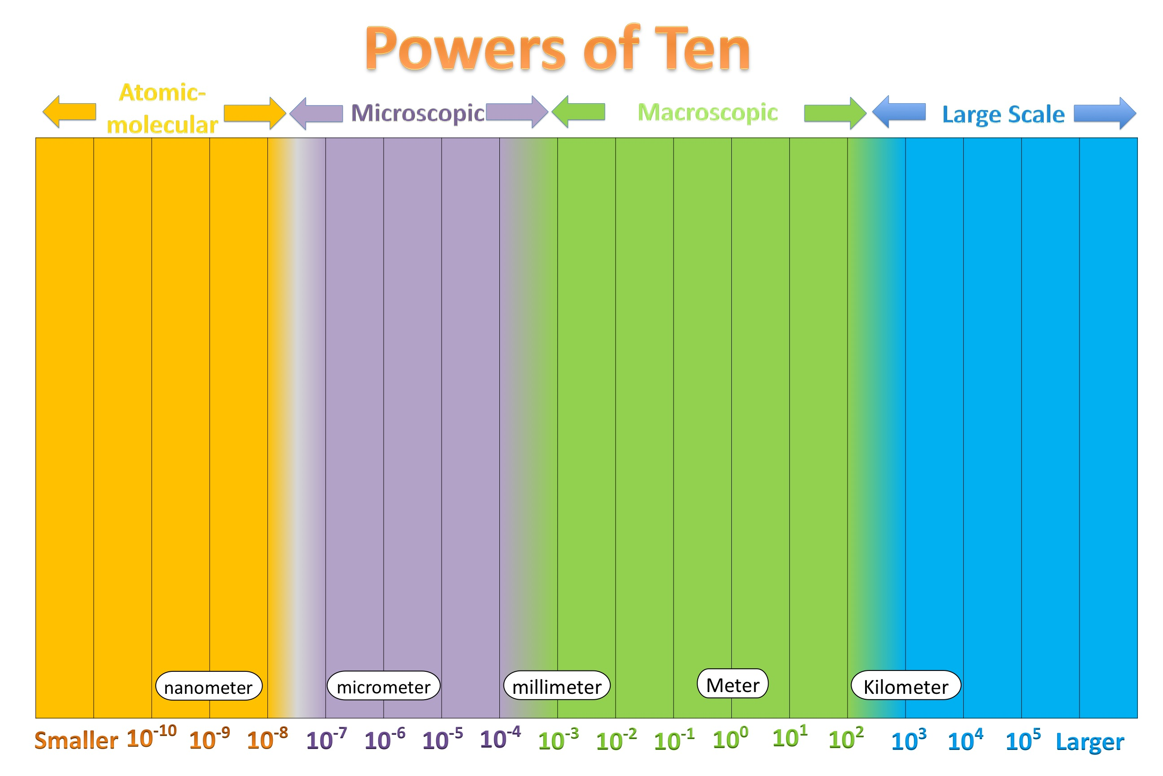

Lesson 6: Disturbance and Dispersal

- Now sort all Macroinvertebrate cards into three piles: macroscopic living things, microscopic living things, and non-living, abiotic items. Record the names of things in the chart below.
Is it a living thing? (Biotic) |  | Is it a non-living thing? (Abiotic)
Macroscopic | Microscopic
- How did you decide what to put in the
- Biotic columns?

- Abiotic column?

- Macroscopic column?

- Microscopic column?

- When you include both the biotic and abiotic components in an area what are you describing? (circle one-you may refer back to your vocabulary list if needed)
species population community ecosystem biome biosphere

- Example of Disturbance: Imagine a Power plant is built along your stream and starts dumping hot water into the stream. Warm water holds less oxygen so the dissolved oxygen amount in the stream will decrease. If the dissolved oxygen decreases to 5 mg/L what might happen to the living and non-living things in the water? Use the Community Change Reasoning Tool to reason through what is happening to the stream environment due to water warming.

- After completing the power plant activity, can you reason through a new example of biological disturbance that has or is happening in your area or in the news? Take this example through the steps in the reasoning tool, and fill out the tool.

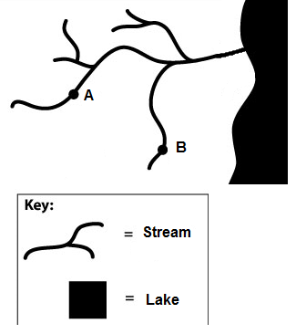
- Example of Dispersal: Many factors determine what organisms can live in an area: sunlight, nutrients, available food. Consider the drawing on the right. The streams labeled A and B are five miles apart. The land in between is mostly corn fields with some roads and houses.

Randomly pick 3 organism cards from the deck and fill out the table below. Which of these organisms do you think could move from stream A to stream B?

Name of organism | Would it be able to get from stream A to stream B?  Yes or No | Describe How | What traits of the organism did you use when making your decision?  Is there another part of the organisms life cycle that might make the movement easier?
1.

2.

3.

- Besides the abiotic factors you measured, what else could have influenced the diversity of the organisms you found in the two types of leaf packs? Think back to the discussions the class has had about other types of factors that influence an organism.

Other Abiotic Resources or Conditions
Biotic Interactions:

Dispersal
Other

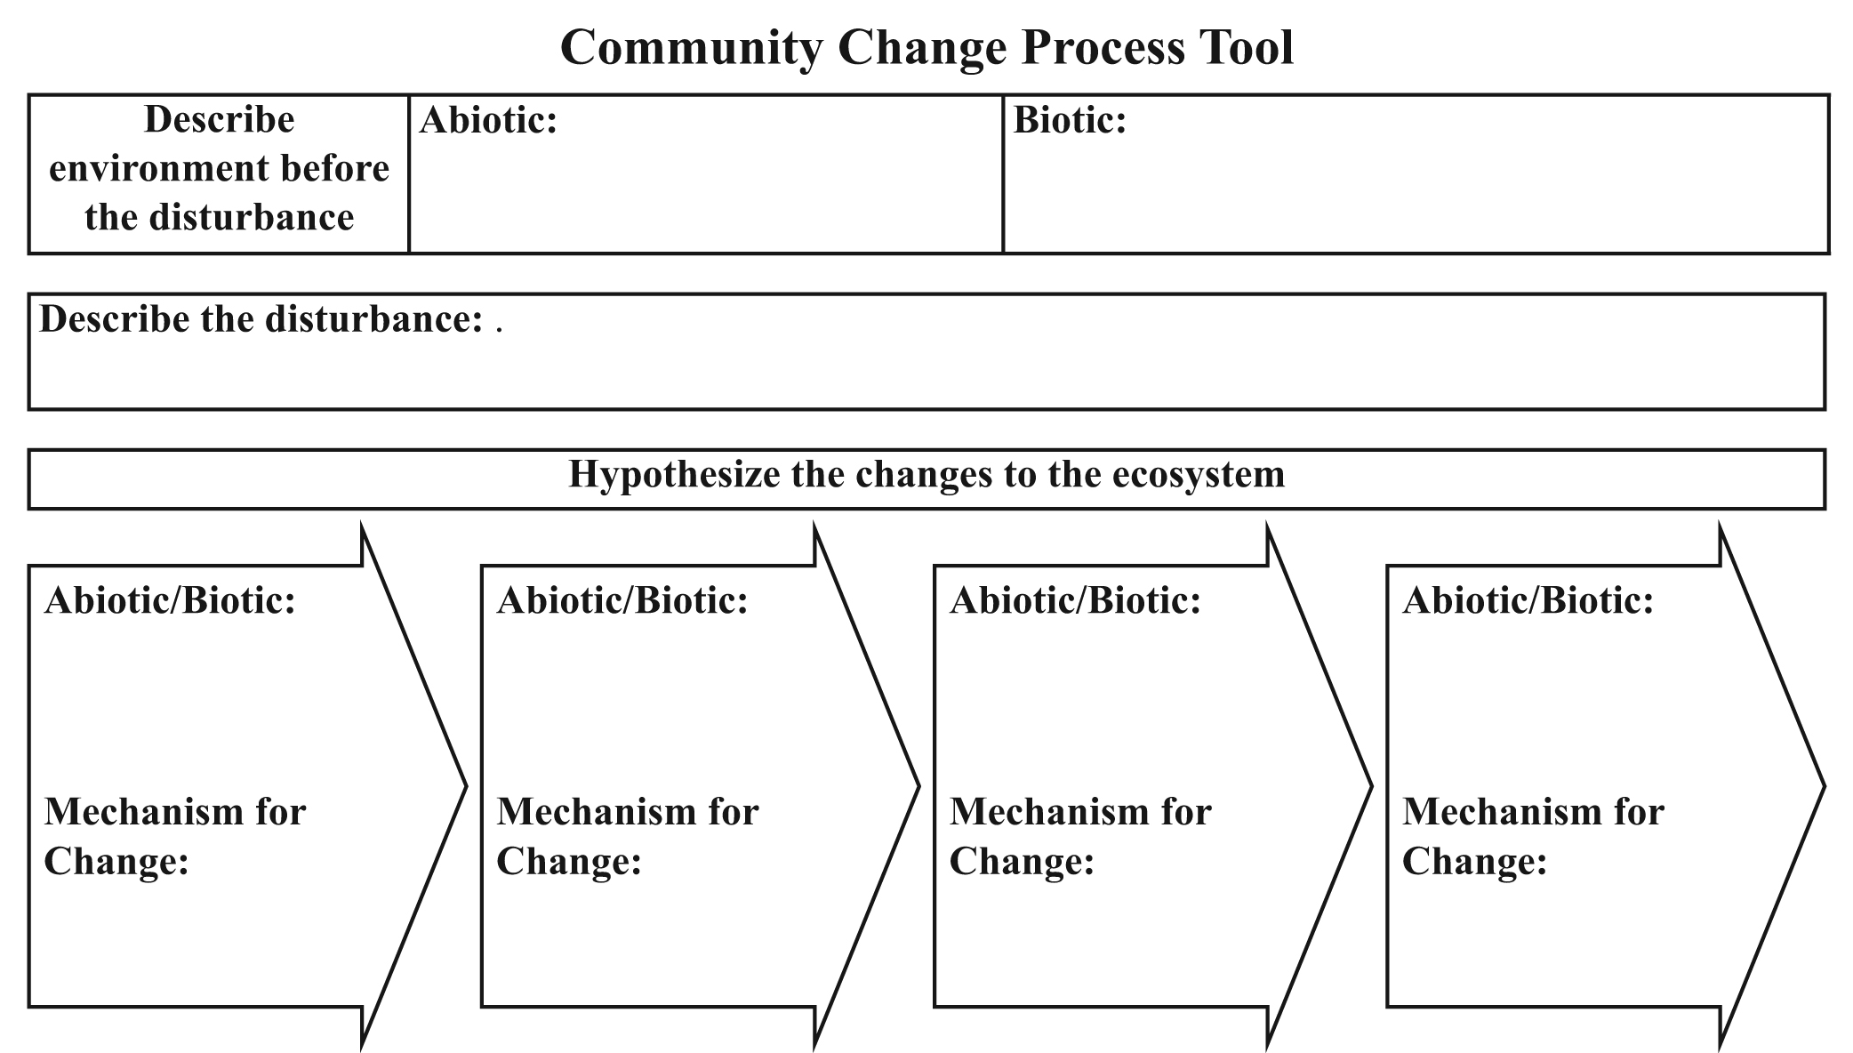

Lesson 7: Who Eats Whom?

Name: _________________________________________ Period: ___________

      - Pick an organism from your food web (ex: mayflies):

What feeding group is your organism in?

Use your food web drawing to predict what you think would happen to the other organisms found in the leaf pack if your chosen group of organisms did not exist in the stream

      - Was there more than one type of collector in your leaf pack?

a. Why do you think that is?

b. Why is there not just one best type of collector?

c. What would happen to the abiotic environment if collectors disappeared from the stream?

d. What would happen to the biotic environment if collectors disappeared from the stream?

e. What would happen to the abiotic and biotic environment if there were three types of collectors and one of them disappeared from the stream?
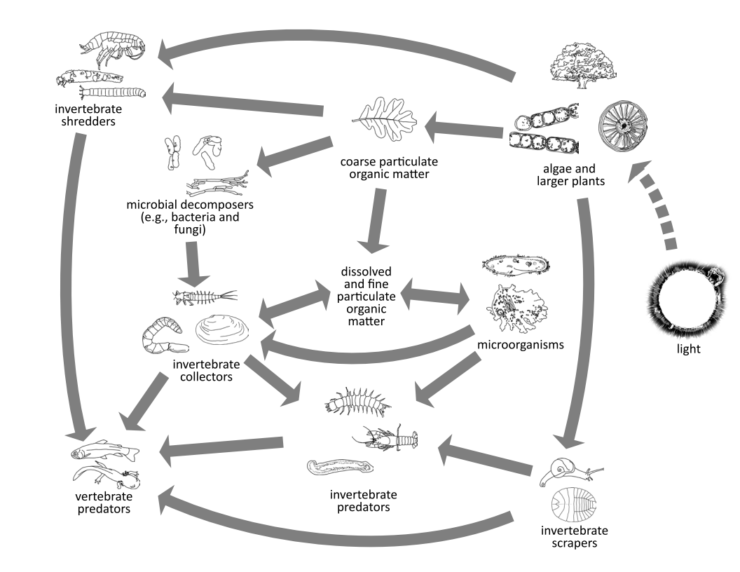
      - Imagine over time that small trees on the banks of your stream grew into really big trees.
  - How would the growth of the trees affect the amount of sunlight that hits the stream?

  - Pick an organism from the food web above and explain how the change in sunlight hitting the stream would affect that organism.

  - How would the change in sunlight affect an organism that is directly connected to your organism in the food web?

      - Complete the table below. Hint: The key is to think about what the food does when it is in the environment.

Feeding Group | What organism does this group eat? How does it get its food? | How will a decrease in that feeding group affect the abiotic environment? | How will the change to the abiotic environment affect another organism?
Decomposers

Scrapers
Collectors
Shredders
Producers

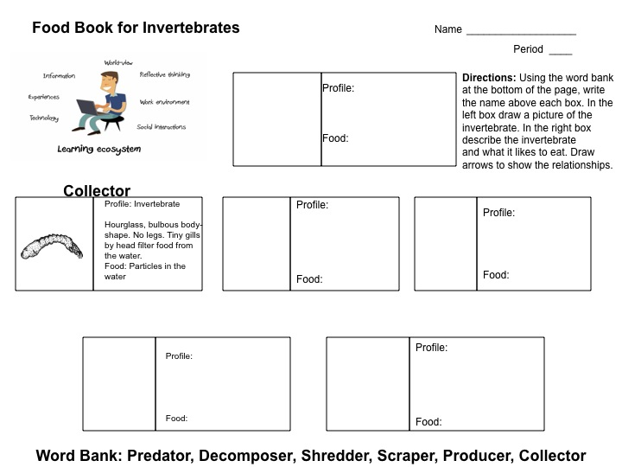

Lesson 8: What affects what lives in leaf packs?
Name: _________________________________________ Period___________
- Calculate the total number of individuals in each macroinvertebrate group using the data collected by your whole class.
 | Total Number
Group | Riffle | Pool
Stoneflies
Mayflies
Dragonflies
Damselflies
True Flies / Black Flies
Crane Flies
Caddisflies
Snails
Beetles
True Bugs

- Create a bar graph below comparing the number of individuals in each group from the two types of packs, riffles and pool.

- Using the data your teacher provides, describe the differences in abiotic conditions between the riffles and pools:

-The amount of dissolved oxygen was higher in(circle one): Riffle or Pools

-The pH of the water was:
Riffle: 0 1 2 3 4 5 6 7 8 9 10 11 12 14
Pool: 0 1 2 3 4 5 6 7 8 9 10 11 12 14

-The temperature of the water was: Riffle: ______°F Pool: ______°F

- Why might the groups that you found in pools vs. riffles be different? You may want to use your answer to question number 3 and your bar graph to help you answer this question.

- Besides the abiotic factors you measured, what else could have influenced the diversity of the organisms you found in the two types of leaf packs?

- If you took a bunch of invertebrates from a stream in New York and put them in a stream in California, what do you think would happen? Explain why. Give as many reasons as you can.

- What additional information would you need to know to feel more confident in your answer?

Lesson 9: Comparing the Stream to a New Ecosystem

Name: _________________________________________ Period___________

- What ecosystem are you exploring today? What makes it an ecosystem?

- Draw a food web diagram for this new ecosystem

- What parts of your new ecosystem would you want to know more about in order to make a more complete food web? In other words, what parts might be missing but you’d need to find out more to add?

- Compare the feeding groups between the stream ecosystem and this new ecosystem
  - Name some similarities between the stream and this new ecosystem:

  - Name some differences between these ecosystems:

- Can you think of any changes in the biological community of your familiar ecosystem that would change the abiotic environment of the ecosystem?

- Would these changes affect the biological community? How?

